Jokes

**What did the fish say when he swam into the wall?**

**Dam! (Shay)**

**What do you call a can opener that doesn’t work?**

**A can’t opener! (Dylan)**

Acknowledgements

Congratulations to all our pupils that are now representing their clubs, counties, provinces and country in various sporting events. There are far too many to mention individually, but we are so proud of all our pupils both past and present.



**Did you know:**

1. A dogs nose is unique the same as a persons fingerprint is unique to them. (Holly)
2. Laois is the only county that doesn’t touch any county that touches the sea. (Charlie)



**Riddle me this, riddle me that…….**

What can go up a chimney down but cannot come down a chimney up?

(Isabel)

*Answer will be put on the Student Council page on the website.*

** World Book Day **

We are celebrating World Book Day this Friday 11th March. The children can dress up as their favourite book character. The cost is €2 per child, max €5 per family. All proceeds go to the Ukraine appeal. Special Guest, Frances Harney, the Story Teller will be entertaining the children on the day.

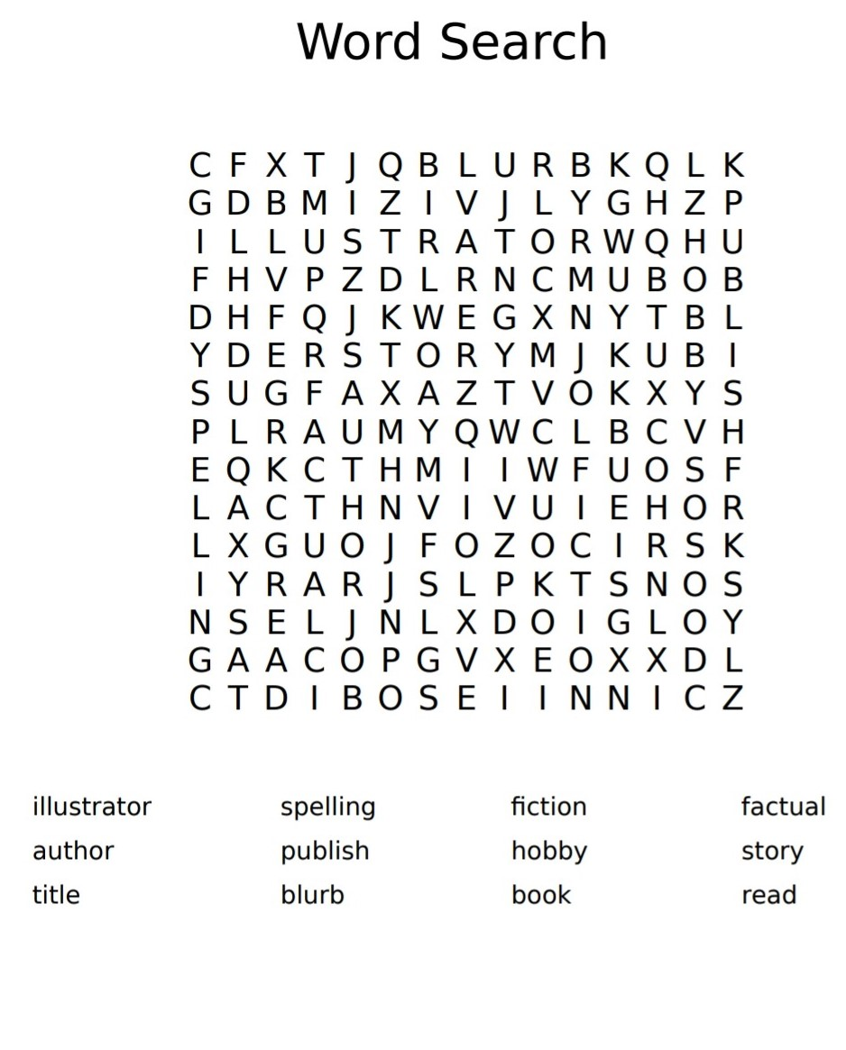

We

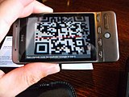 

**The QR Code will bring you to our website where you can catch up on all the latest news and see all the new photos. Simply scan your phone camera over the code and the link will appear!**